# V2V COMMUNICATION APROACH TOWARDS AUTONOMOUS DRIVING USING

# VANET & TELEMATICS

A Project Report submitted in partial fulfillment of the requirements

for the award of the degree of

**Bachelor of Engineering**

**In**

**Computer Science & Engineering**

**Submitted by**

**Anant Sinha**

**Vishal Mahesh Dixit**

**Ganesh Viththal Gawali**

**Vaishnavi Vijayrao Bhoyar**

**Santoshi Ashok Nawkhare**

**Under the Guidance of**

**Prof. Pranjali B. Ulhe**



**Computer Science & Engineering**

**J D College of Engineering and Management, Nagpur-441501**

**Affiliated to Rashtrasant Tukadoji Maharaj Nagpur University, Nagpur.**

**Year 2019 - 20**

# V2V COMMUNICATION APROACH TOWARDS AUTONOMOUS DRIVING USING

# VANET & TELEMATICS

A Project Report submitted in partial fulfillment of the requirements

for the award of the degree of

**Bachelor of Engineering**

**In**

**Computer Science & Engineering**

**Submitted by**

**Anant Sinha**

**Vishal Mahesh Dixit**

**Ganesh Viththal Gawali**

**Vaishnavi Vijayrao Bhoyar**

**Santoshi Ashok Nawkhare**

**Under the Guidance of**

**Prof. Pranjali B. Ulhe**

**Name of Department**

**J D College of Engineering and Management, Nagpur-441501**

**Affiliated to Rashtrasant Tukadoji Maharaj Nagpur University, Nagpur.**

**Year 2019 - 20**

**DECLARATION**

We hereby declare that the work presented in this project report entitled, **“V2V Communication Approach Towards Autonomous Driving Using VANET & Telematics”** in the subject **Computer Science & Engineering** in the faculty of Science and Technology is the original contribution carried out by us under the guidance of Prof. Pranjali B. Ulhe, Computer Science & Engineering, J D College of Engineering and Management, Nagpur. This work has not been submitted to any other University or Institution for the award of any degree or diploma or certificate course.

Place: Anant Sinha

Date: Vishal Mahesh Dixit

Ganesh Viththal Gawali

Vaishnavi Vijayrao Bhoyar

Santoshi Ashok Nawkhare

**CERTIFICATE**

This is to certify that the project report entitled, **“V2V Communication Approach Towards Autonomous Driving Using VANET & Telematics”** in the subject **Computer Science & Engineering** in the faculty of Science and Technology submitted by **Anant Sinha, Vishal Mahesh Dixit, Ganesh Vithtal Gawali, Vaishnavi Vijayrao Bhoyar, Santoshi Ashok Nawkhare** to **Rashtrasant Tukadoji Maharaj Nagpur University, Nagpur** for the award of the degree of **Bachelor of Engineering** is a bonafide record of work carried out by them under my supervision. The contents of this Project Report, in full or in parts, have not been submitted or published to any other Institute or University for the award of any degree or diploma.

**Prof. Pranjali B. Ulhe**

Computer Science & Engineering

Forwarded to:

**Prof. Supriya Sawashre**

Project Coordinator

**Prof. Madhuri Pal**

Head of the Department

Computer Science & Engineering

Dr. S.R. Choudhari

Principal

##### CERTIFICATE OF APPROVAL

This is to certify that the Project Report on **V2V Communication Approach Towards Autonomous Driving Using VANET & Telematics** is approved work done by

##### Anant Sinha

##### Vishal Mahesh Dixit

##### Ganesh Viththal Gawali

##### Vaishnavi Vijayrao Bhoyar

##### Santoshi Ashok Nawkhare

in partial fulfillment of the requirements for the award of the degree of **Bachelor of Engineering** in **Computer Science & Engineering** at J D College of Engineering & Management, Nagpur affiliated to **Rashtrasant Tukadoji Maharaj Nagpur University, Nagpur** during the academic year 2019 - 2020.

|  |  |
| --- | --- |
| **Prof. Pranjali B. Ulhe** | **Prof. Madhuri Pal** |
| Guide | Head of the Department |

_____________________________________________________________

Project Examination held on

**Internal Examiner/ Guide External Examiner**

**INDEX**

|  |  |
| --- | --- |
| **Title** | **Page No.** |
| **Acknowledgement** | **i** |
| **List of Figures** | **ii** |
| **List of Tables** | **iii** |
| **Abbreviations and Symbols** | **iv** |
| **Abstract** | **v** |

**CONTENTS AT GLANCE**

|  |  |  |  |
| --- | --- | --- | --- |
| **Title** | | | **Page No.** |
| **Chapter 1 INTRODUCTION** | | |  |
|  | 1.1 Brief Outline of Project | |  |
|  | 1.2 Overview of Project Report | |  |
| **Chapter 2 LITERATURE SURVEY** | | |  |
|  | 2.1 Literature Review | |  |
|  | 2.2 Research Gap | |  |
|  | 2.3 Problem Statement | |  |
|  | 2.4 Objectives | |  |
| **Chapter 3 RESEARCH METHODOLOGY** | | |  |
|  | 3.1 Methodology | |  |
|  |  | 3.1.1 Idea Generation |  |
|  |  | 3.1.2 Literature Review |  |
|  |  | 3.1.3 Study of VANET |  |
|  |  | 3.1.4 Study of Telematics |  |
|  |  | 3.1.5 Definition of Research Gap |  |
|  |  | 3.1.6 Proposed Statement |  |
|  |  | 3.1.7 Prototyping & Implementation |  |
|  |  | 3.1.8 Testing |  |
|  |  | 3.1.9 Result & Conclusion |  |
| **Chapter 4 EXPERIMENTATION/ IMPLEMENTATION/**  **SIMULATION** | | |  |
|  | 4.1 Module Development | |  |
|  | 4.2 Client Development | |  |
|  | 4.3 Server Development | |  |
|  | 4.4 Arduino Programming | |  |
|  | 4.5 Client-Server Connection | |  |
| **Chapter 5 RESULTS AND DISCUSSIONS** | | |  |
| **Chapter 6 SUMMARY AND CONCLUSION** | | |  |
|  | 6.1 Summary | |  |
|  | 6.2 Conclusion | |  |
|  | 6.3 Scope for Future Work | |  |
| **REFERENCES** | | |  |
| **ANNEXURES** | | |  |
|  | Paper published | |  |
|  | Copy Right Certificate | |  |
|  | NPTEL Elite Certificate | |  |
|  | Plagiarism Report | |  |
|  | Grammarly Report | |  |
|  | Photo Gallery | |  |
|  | Bibliography | |  |

##### ACKNOWLEDEMENT

We express our sincere gratitude, for giving us the opportunity to work on the project during our final year of B.E.

We owe our sincerest gratitude towards **Dr. S. R. Choudhari**, Principal J D College of Engineering & Management, Nagpur, for providing the platform and necessary facilities.

We also express our sincere gratitude towards **Dr. S.V. Sonekar**, Vice Principal and Dean Academics, J D College of Engineering and Management, Nagpur, for continuous support and motivation.

The constant guidance and encouragement received from **Prof. Madhuri Pal**, Head, Department of Computer Science & Engineering J D College of Engineering & Management, Nagpur, has been of great help in carrying out the project work and is acknowledged with reverential thanks.

We would like to thank **Prof. Supriya Sawashere**, Project Coordinator, J D College of Engineering & Management, Nagpur for providing proper guidelines and continuous efforts taken towards the completion of project.

We would like to express a deep sense of gratitude and thanks profusely to our Guide **Prof. Pranjali B. Ulhe**, Department of Computer Science & Engineering, J D College of Engineering & Management, Nagpur. Without his/her wise counsel and able guidance, it would have been impossible to complete the project in this manner.

We would like to thank the members of the Departmental Research Committee for their valuable suggestions and healthy criticism during our presentation of the work. We express gratitude to other faculty members of Computer Science & Engineering Department, J D College of Engineering & Management, Nagpur, for their intellectual support throughout the course of this work.

*Anant Sinha*

*Vishal Mahesh Dixit*

*Ganesh Viththal Gawali*

*Vaishnavi Vijayrao Bhoyar*

*Santoshi Ashok Nawkhare*

**LIST OF FIGURES**

|  |  |  |
| --- | --- | --- |
| **Figure No.** | **Title** | **Page No.** |
| 1.1 | Infotainment System used in vehicles handled through Android technology |  |
| 1.2 | Classification of VANET |  |
| 1.3 | V2X Communication |  |
| 1.4 a | Telematics unit implemented in car |  |
| 1.4 b | Telematics Unit implemented in car |  |
| 3.1 | Approach |  |
| 3.2 | Project’s Methodology |  |
| 4.1 | Modules of the Project |  |
| 4.2 | Client Implementation |  |
| 4.3 | Server Implementation |  |
| 4.4 | Remote Car Control Feature |  |
| 4.5 | Client - Server Connection |  |
| 5.1 | App’s Login Page |  |
| 5.2 | App’s Home Screen |  |
| 5.3 | Location Sharing Screen |  |
| 5.4 | Remote Car Control Screen |  |
| 5.5 | Remote Car |  |
| 5.6 | Vehicle Diagnostics Screen |  |
| 5.7 | Server’s Login Page |  |
| 5.8 | Server’s Home Page |  |
| 5.9 | Location Sharing’s Data |  |
| 5.10 | Remote Car Control’s Data |  |
| 5.11 | Vehicle Diagnostics’s Data |  |

**LIST OF TABLES**

|  |  |  |
| --- | --- | --- |
| **Table No.** | **Title** | **Page No.** |
| 3.1 | Literature Review |  |

**ABBREVIATIONS**

|  |  |
| --- | --- |
| VANET | Vehicular Ad-hoc Network |
| MANET | Mobile Ad-hoc Network |
| V2V | Vehicle-to-Vehicle |
| RSU | Road Side Unit |
| DSRC | Dedicated Short Range Communication |
| IVC | Inter-Vehicle Communication |
| RVC | Road-Side Vehicle Communication |
| IVI | In-Vehicle Infotainment |

##### ABSTRACT

VANETs have been gaining signiﬁcant attention from the research community due to their increasing importance for building an intelligent transportation system. A VANET turns every participating vehicle into a wireless router or node. An add-on to neutralize the backdrops of VANET is Telematics. Telematics is an interdisciplinary field that encompasses telecommunications and vehicular technologies. It is a method used for long distance vehicular transmission. Telematics is advantageous in easily gathering the diagnostic data of vehicles like the vehicle speed, engine data etc. Recently, the vehicle to vehicle communication is being done in India through IPv4 connection which has many drawbacks like limited number of addresses, low information security, weak protocol extensibility etc. All these drawbacks can be neutralized by using the IPv6 connection.

The proposed project is a simulation of the real time project. It uses the client-server relationship wherein, the Telematics server will be mounted on the vehicles and all the vehicles or user will act as the clients. The project basically includes three function – Remote car control, Location sharing and Vehicle diagnostics. Proposed project acts as the infotainment system that is embedded in the vehicle and works in collaboration with the Android technology.

### CHAPTER 1

**INTRODUCTION**

* 1. **Brief Outline of the Project**

"Any sufficiently advanced technology is indistinguishable from magic."

-Arthur C Clarke

Concurring to the above given quote, it is likewise evident that the world will be in fact progressed just if the parts identified with IOT are. Furthermore, the vehicles have been a conspicuous part of the population. With the constant increase in the population as well as need for automation, the need for smarter modes of transportation has also been increased. The same concept is empowered by Intelligent Transport Systems (ITS). An ITS is a propelled application on which, epitomizing knowledge as such , plans to give innovative administrations identifying with various methods of transport and traffic to board and empower clients to be more educated and make more secured progressively planned and 'more astute' utilization of transport systems.

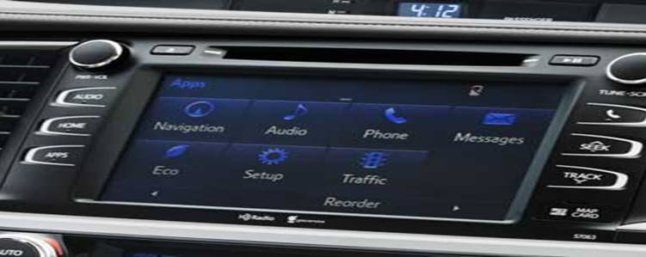 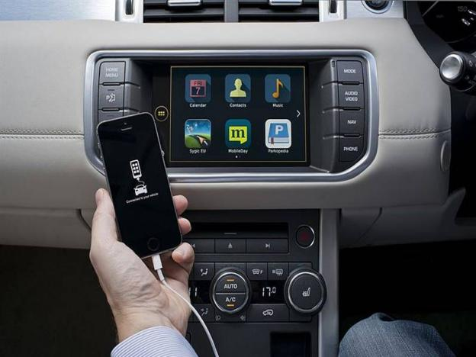

Figure 1.1 Infotainment System used in vehicles handled through Android

Coinciding to the fact that our society is progressing towards a better and more automated future, the proposed project has been chosen as a tiny contribution in facilitating the movement towards that future. As the key operated ignition in the olden days was replaced by the Start button. That replaced the need of manually opening the bonnet and igniting the engine by ignition through a button and reducing the human effort. The proposed project aims to take a step forward by offering to perform some more important tasks through the user's Android phone. The proposed project basically offers three main principles-

* Remote Car Control
* Location Sharing
* Vehicle Diagnostics

The proposed project is governed by mainly two concepts- VANET and Telematics. Both of which in co-ordination with each other will allow secured and faster communication between vehicles, user authentication etc. These phenomena are elaborated more below.

* + 1. **VANET**

A VANET utilizes vehicles as versatile hubs in a MANET to make a portable system. . As vehicles fall out of the flag range and drop out of the system, different vehicles can participate, associating vehicles to each other so that a versatile Internet is made. It is evaluated that the main frameworks that will incorporate this innovation are police and fire vehicles to speak with one another for well-being purposes. Car organizations like General Motors, Toyota, Nissan, Daimler Chrysler, BMW and Ford advance this term.

The majority of the worries important to versatile specially appointed systems MANETs are of enthusiasm for VANETs, however the subtleties contrast. Instead of moving indiscriminately, vehicles tend to move in a sorted out manner. GPS and route frameworks may profit, as they could be coordinated with traffic reports to give the quickest course to work.

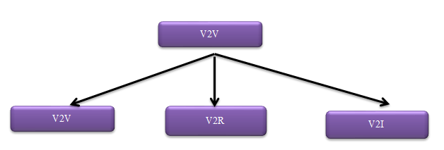

Figure 1.2 Classification of VANET

Vehicles communicate with one another by means of IVC just as with roadside base stations by means of RVC. Inside the Communications Society, there is a Technical Subcommittee on VNTA.The contract of this board of trustees is to effectively advance specialized exercises in the field of vehicular systems, V2V, V2R and V2I correspondences, gauges, interchanges empowered street and vehicle security, constant traffic checking, crossing point the board advancements, future telematics applications. Viable estimates, for example, media correspondence between vehicles can be empowered also techniques to follow car vehicles.

In VANET isn't anticipated to supplant current portable correspondence principles. Car vehicular data can be seen on electronic maps utilizing the Internet or particular programming. In VANET can be utilized as a major aspect of car gadgets, which needs to recognize an ideally insignificant way for route with negligible traffic power.

**1.1.1.1 V2V Communication**

V2V communication includes a remote system where vehicles send messages to one another with data about what they're doing. This information would incorporate speed, area, bearing of movement, braking, and loss of soundness. Vehicle-to-vehicle innovation utilizes DSRC, a standard put forward by bodies like FCC and ISO. Now and then it's depicted just like a Wi-Fi arrange on the grounds that one of the conceivable frequencies is 5.9GHz, which is utilized by Wi-Fi, however it's increasingly exact to state "Wi-Fi like." The range is up to 300 meters or 1000 feet or around 10 seconds at parkway speeds (not 3 seconds as certain reports state).

On the principal vehicles, V2V admonitions may go to the driver as a caution, maybe a red light that flashes in the instrument board, or a golden then red alarm for heightening issues. It may show the course of the risk. All that is liquid for the time being since V2V is as yet an idea with a few thousand working models or retrofitted test vehicles. It's additionally energizing for an administrator or writer to see a vehicle that stops or swerves, not one with a glimmering light.

**1.1.1.2** **V2R Communication**

V2R Communication is the transaction between the roadside unit and vehicles. In case of the heterogeneous nodes, they cannot communicate with each other directly, so the communication between them is done through the roadside unit.

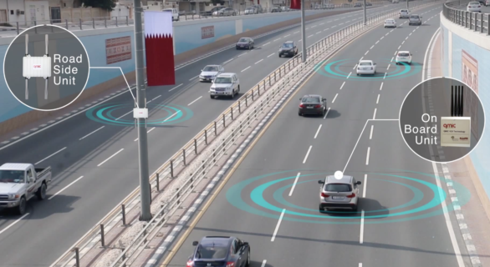

Figure 1.3 V2X Communication

**1.1.2 Telematics**

Telematics is a technique for observing an asset (vehicle, truck, heavy gear, or even ship) by utilizing GPS and on-board diagnostics to record developments on a mechanized guide. Telematics is a technique utilized for long distance vehicular transmission. It resembles a black box in the plane. Be that as it may, today, it tends to be actualized in advanced cells likewise yet this innovation is in developing stage in India. The monetarily developed nations, for example, USA, Japan and Germany have officially actualized this telematics in cars and have brought transformation.

Suppose that you have a highly automated system in your vehicle that is capable of informing you about nearly every detail — from speed and idling, to fuel use, low tire pressure, etc. This data can mean saving money on upkeep costs by better observing vehicles or improving Eco-friendliness by getting familiar with driving propensities. The majority of this portrays the universe of telematics, otherwise called GPS fleet tracking.

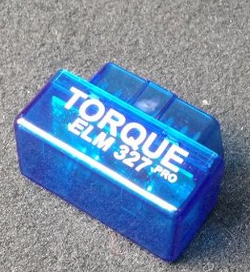 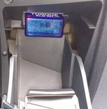

Figure 1.4 a Telematics Server Unit Figure 1.4 b Telematics unit implemented in car

**1.2.2.2 Applications of Telematics**

From the business viewpoint, telematics is commonly utilized as an equivalent word of vehicle telematics. This is a direct result of the expansive uses of telematics arrangements in the car business. The most well-known utilizations of telematics incorporate vehicle attendant frameworks, installed network administrations, protection dependent on driving conduct or armada the board administrations.

Telematics frameworks intended for armadas empower the trading of data between a focal area and the individual armada vehicles, for example, trucks, ambulances, city vehicles or school transports. Apparently, Telematics is a field committed just to expert ventures and explicit target gatherings. Truth be told, practically all of us can profit by telematics.

* 1. **Overview of Project Report**

Chapter 2 deals with the literature survey. The block diagram of the system is explained in Chapter 3, giving an overall view of the techniques used in the system. Chapter 4 deals with System hardware and Chapter 5 with system software and flowcharts. Chapter 6 contains result which is explained through snapshots and quantity analysis. Chapter 7 contains conclusion and scope for future work.

### CHAPTER 2

**LITERATURE SURVEY**

* 1. **Literature Review**

Many scientists have completed research work in the region of V2V communication. The research shows that the work has been done in Automobile Industry using VANET and Telematics phenomenon. But most of the component has yet to be implemented and mainly in India. In the present chapter literature audit is completed covering the diverse issues identified with V2V communication.

Do- Hyun Kim proposed a system on the interoperability of the Telematics contents in the paper “**A Framework For Interoperability Of Vehicular Telematics Contents” [2014]** in **IEEE.** Their research is based on the vehicular telematics such as car navigation systems, traffic information systems, and location-based systems (LBS) are getting popular. Be that as it may, substance for vehicular telematics is created by various substance suppliers and their information groups are not perfect. Consequently, it is hard to incorporate or trade substance, e.g., route maps, traffic data, focal points (POI), and so forth, for different telematics administrations. In the framework, they have proposed a telematics substance passage (TCG) framework, which empowers the framework to incorporate diverse telematics substance, so the substance can be interoperable. The proposed TCG underpins an inquiry work dependent on a web-administration innovation. Their research is to bind telematics contents consumers and its providers, and to integrate existing heterogeneous telematics contents. So their work is focused on the interoperability of telematics contents. Interoperability implies the sharing of data semantic as well as data syntactic. And it is classified into two groups; data interoperability and service interoperability. The former can be guaranteed by a common data model to integrate different road network models into the common model. The latter is to provide the service interfaces with standard API. Their study is focused on the view of data interoperability.

Devyasri G proposed a system for advanced fuel tracking in the paper **“Advanced Fuel Level Tracking System Using Telematics Unit” [2015]** in **IEEE.** Telematics is a famous innovation which consolidates broadcast communications and informatics. The whole framework comprises of TeCU Telematics Control Unit, server and site page application to screen and to detect abundant data's gotten from vehicle over the air. Telematics Control Unit (TeCU) needs to be structured and created, which could be utilized progressively and off time observing. The client can make a site page application and screen the vehicle update data's and mappings with fine exactness. In this way, framework gives sufficient data to armada administrator with respect to course/bearing taken by driver, stoppages, high increasing speed, vehicle area, speed, inert mode, AC ON or OFF, vehicles unit information's, RPM, unexpected braking ,date, time, and so on. All these vehicle data's from TeCU could be refreshed to the Server; this is conceivable through GPRS correspondence. In this manner server dispatch's all data's totally to end client site page. This framework could be widely utilized in business vehicles and in steady supplies. GSM/GPRS module is utilized to build up correspondence to a PC.

Keshav Bimbraw has explained the, trends in autonomous vehicles in the past, present and future in the paper **“Autonomous Cars: Past, Present and Future A Review of the Development in the Last Century, the Present Scenario and the Expected Future of Autonomous Vehicle Technology” [2015]** in **IEEE.** The paper elaborates that we see an uncommon change in self-governing vehicle innovation since 1920s, when the primary radio controlled vehicles were planned. In the ensuing decades , we see genuinely self-sufficient electric vehicles controlled by implanted circuits in the streets. By 1960s, self-sufficient vehicles having comparative electronic guide frameworks came into picture. 1980s saw vision guided self-governing vehicles, which was a significant achievement in innovation and till date we utilize comparative or changed types of vision and radio guided innovations. It states that present day autonomous vehicles can detect their neighborhood condition, arrange various types of items that they distinguish, can decipher tangible data to recognize proper route ways while obeying transportation rules. Impressive headways have been made in giving a suitable reaction to unforeseen conditions where either a backfire can happen in the vehicular frameworks or some medium in the outside condition may not carry on as anticipated by inward models.

Seilendria A. Hadiwardoyo, Subhadeep Patra, Carlos T. Calafate, Juan-Carlos Cano and Pietro Manzoni (2018) introduced the paper “**An Intelligent Transportation System Application for Smart phones Based on Vehicle Position Advertising and Route Sharing in Vehicular Ad-Hoc Networks”** in **Springer** Science Business Media. This paper Alarming drivers about approaching crisis vehicles and their courses can incredibly improve their movement time in clogged urban areas, while decreasing the danger of mishaps because of interruptions. This is made conceivable by making a system of vehicles prepared to do legitimately imparting between them. The client can, along these lines, take driving choices in an opportune way by thinking about approaching cautions. One of the primary worries in transportation is well being issues, which pull in the consideration of both research networks and the general public. VANET can be an efficient arrangement in the ITS field to take care of the issue of well being issues and wastefulness in rush hour gridlock motorways since they permit vehicles to speak with each other, accordingly permitting the trading of traffic-related information. With the objective of decreasing the likelihood of traffic mishaps, late examinations incorporate the improvement of well-being related applications.

Shouyang Wei, Yuan Zou, Xudong Zhang, Tao Zhang, and Xiaoliang Li (2018) **“An Integrated Longitudinal and Lateral Vehicle Following Control System with Radar and Vehicle-to-Vehicle Communication” [2018]** in **IEEE** . This paper A control system receiving on-board radar sensor and V2V communication has been created to satisfy mechanized vehicle following in the longitudinal also, horizontal bearings. Initial, a straight feed forward and input controller compelled by the string strength is intended to follow the speed of the first vehicle and guarantee a safe between vehicle separation. In the Grand Cooperative Driving Challenge (GCDC) , a few vehicles participated in both urban and expressway driving situations, to encourage the organization and research of agreeable driving frameworks dependent on the blend of V2V and V2I communication and the best in class of sensor combination and control . Its disservice is that extra sensors or V2V are expected to gain position and movement conditions of the former vehicle to accomplish sidelong following control precisely, while the street following technique can utilize the ease camera to acknowledge path keeping when the between vehicle run isn't excessively little.

Youngho Park, Chul Sur , Si-Wan Noh , and Kyung-Hyune Rhee **, “Secure Vehicle Location-Sharing for Trajectory-Based Message Delivery on VANET ” [2017]**  in **IEEE** . This paper Direction based message conveyance is a message sending plan that uses the message goal vehicle's direction to convey messages to moving vehicles from infrastructure hubs, for example, side of the road units in vehicular specially appointed systems. In any case, from a security point of view, clients need their driving areas not to be presented to others with the exception of their ideal senders for area protection safeguarding. Along these lines, right now, propose a protected area sharing framework to permit a vehicle to impart its driving direction to side of the road units approved by the vehicle. It is pattern of current vehicles to prepare OBU gadgets which permit vehicles convey to one another as well as side of the RSU. Subsequently, exceptional, assortment of VANET applications utilizing vehicle-to-vehicle (V2V) furthermore, vehicle-to-framework (V2I) interchanges have been introduced to give not just open to driving conditions yet in addition significant infotainment benefits out and about.

Pavel Shilin, Ruslan Kirichek, Alexander Paramonov, and Andrey Koucheryavy demonstrated how to connect the VANET segments in the paper “**Connectivity of VANET Segments Using UAVs**” [**2016**] in **Springer**. It illustrates that VANET is step by step turning out to be progressively perceived and intriguing subject of research. The IEEE association has too built up a working gathering IEEE 1609, which grows family guidelines for WAVE and IEEE 802.11p and characterizes organize design, set of administrations and interfaces, all in all, intended to make a wide scope of arrangements, including improving well-being of street traffic, route, computerized development of vehicles one after another. The hub is a vehicle right now, trades information with other vehicles through remote radio. The hubs of such system are equivalent in rank. Another, somewhat comparative class systems are Flying Ubiquitous Sensor Networks, which were intended for uses of observing and information assortment and the board, formation of impermanent correspondence hubs utilizing UAVs. Having set of projects and calculations on the board, UAVs is capable with high effectivity to serve earthbound hubs, to trade data with one another, to facilitate its activities in the air, guaranteeing a high inclusion of radio availability not at all like earthbound remote systems. The target compound of different gatherings of vehicles can be tended to both by a solitary UAV, and by a swarm of UAVs.

Giuseppe Lugano introduced the paper “ **Virtual Assistants and Self-Driving Cars: To what extent is Artificial Intelligence needed in Next-Generation Autonomous Vehicles?** ” [**2017**] in **IEEE**. In This paper Self-driving autos are innovatively a reality and in the following decade they are relied upon to arrive at the most elevated level of robotization. While there is general understanding that a progressed human-self-governing vehicle (HA V) collaboration is vital to accomplish the advantages of self-driving autos, it is less clear what job counterfeit insight (AI) should play right now. By drawing from prior reflections on mechanization, robots and wise operators, it will at that point distinguish a progression of issues to be tended to by established researchers, strategy producers and the car industry partners.robotized driving framework of all parts of the dynamic driving undertaking under all roadway and ecological conditions that can be overseen by a human driver.

Michal Taraba, Juraj Adamec, Matus Danko, Peter Drgona introduced the paper “ **Utilization of modern sensors in autonomous vehicles** ” [**2018**] in **IEEE**. In this paper, these days present day vehicles, around 100 microcomputers that give the driver solace, help, and security are executed. Hardware frameworks control practically the entirety of the works in the vehicle and because of this reality, there are endeavors to blend V2V and V2I data trade. Propelled Driver Assistance Systems (ADAS) address more intricate and muddled undertakings for the driver. The decrease in the quantity of mishaps and the seriousness of mishaps is, as indicated by EU targets, the most significant one, an European objective as well as a worldwide one, that influences the entire of society.

1. Banerjee , S.Bose , A.Chakraborty , T.Samadder , Bhaskar Kumar , T.K.Rana introduced the paper “**Self Driving Cars: A Peep into the Future**” [**2018**] in **IEEE**. In this paper, a driverless, environmentally friendly power vitality fueled, crash ensured and GSM goal guided vehicle. A GPS module precisely tracks the area of the vehicle, source furthermore, goal, and mapping the co-ordinates gives route speeds of the vehicle is consequently constrained by keeping a safe separation, which is a component of speed, with the vehicle in front. Keeping up a unique speed with the front vehicle or an hindrance is effectively done here with separation estimating sensors. Stepper engine controlled pivoting sensor is utilized at the hour of evolving path.
   1. **Research Gap**

Depending on the research, in the previous accomplished projects either VANET or Telematics is used to build a connection between the vehicular nodes, which may not be able to ensure much reliable and faster communication at times, unlike the combination of both these technologies. In addition to that, all the earlier projects use the cellular networks for the communication that may be unreliable when the user is in a rural area or in the absence of the cellular network (during natural calamities like storms, heavy rains, etc.). This may make the system incompetent to serve the purpose it is built for.

* 1. **Problem Statement**

A lot of research has been carried out in the fields of VANET and Telematics separately. These approaches seem to work properly in the technically advanced areas, but lack reliability of message transfer between vehicles, faster communication, secure routing etc. sometimes. Moreover, the use of cellular network makes it even more unreliable due to the unavailability of the network at times.

* 1. **Objectives**
* To implement VANET and Telematics together to improve quality of vehicular communication.
* To eliminate the dependence on cellular network.
* To make the communication faster and more reliable.

### CHAPTER 3

**RESEARCH METHODOLOGY**

* 1. **Methodology**

Methodologyis the precise, hypothetical analysis of the procedures applied to a field of study. It consists of the theoretical analysis of the body of methods and principles associated with a branch of knowledge. Likewise, the proposed project also follows the Step-wise approach to achieve the final result. The Methodology followed for the proposed project is given below which is represented in the form of block diagram.

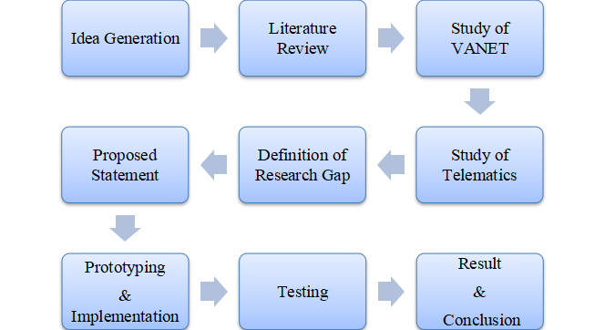

Figure 3.1 Methodology

**3.1.1 Idea Generation :-**

Idea generation is the inventive procedure or methodology that is basically utilized by us so as to figure out solutions for any number of troublesome difficulties. It includes thinking of numerous ideas in a group discussion, choosing the best idea, attempting to make an arrangement to implement the idea, and afterward really taking that idea and incorporating it.

Alike we have also followed the same Approach, i.e. we have considered the fact of implementing the knowledge of Computer Science in Automotive Industry. Thus we came up with the idea of V2V Communication with the help of VANET & Telematics.

**3.1.2 Literature Review :-**

After the process completion of Idea Generation, we move to our next step, i.e the Literature Review. Literature Review gives the brief description about the various Research made by the various Researches and published their work in the Prime Journals and Conferences. The research is mainly conducted on the topic of VANET & Telematics technology individually but the none described about the combination of both. The more description on the research has been illustrated in the Literature review Chapter given earlier.

|  |  |  |  |
| --- | --- | --- | --- |
| **Sr No** | **Paper Name** | **Publication**  **&**  **Year** | **Author** |
| 1. | An Integrated Longitudinal and Lateral Vehicle Following Control System with Radar and V2V Communication | IEEE,  2018 | Shouyang Wei, Yuan Zou, Xudong Zhang , Tao Zhang , Xiaoliang Li |
| 2. | An Intelligent Transportation System Application for Smart phones Based on Vehicle Position Advertising and Route Sharing in Vehicular Ad-Hoc Networks | Springer,  2018 | Seilendria A. Hadiwardoyo, Subhadeep Patra , Carlos T. Calafate , Juan-Carlos Cano, Pietro Manzoni |
| 3. | Utilization of modern sensors in autonomous vehicles | IEEE,  2018 | Michal Taraba, Juraj Adamec , Matus Danko , Peter Drgona |
| 4. | Self Driving Cars: A Peep into the Future | IEEE,  2018 | T.Banerjee , S.Bose , A.Chakraborty , T.Samadder , Bhaskar Kumar , T.K.Rana |
| 5. | Secure Vehicle Location-Sharing for Trajectory-Based Message Delivery on VANET | IEEE,  2017 | Youngho Park , Chul Sur , Si-Wan Noh , and Kyung-Hyune Rhee |
| 6. | Virtual Assistants and Self-Driving Cars: To what extent is Artificial Intelligence needed in Next-Generation Autonomous Vehicles? | IEEE,  2017 | Giuseppe Lugano |
| 7. | Connectivity of VANET Segments Using UAVs | Springer,  2016 | Pavel Shilin , Ruslan Kirichek , Alexander Paramonov , and Andrey Koucheryavy |
| 8. | Advanced Fuel Level Tracking System Using Telematics Unit | IEEE,  2015 | Devyasri G |
| 9. | Autonomous Cars: Past, Present and Future A Review of the Development in the Last Century, the Present Scenario and the Expected Future of Autonomous Vehicle Technology | IEEE,  2015 | Keshav Bimbraw |
| 10. | A Framework For Interoperability Of Vehicular Telematics Contents | IEEE,  2014 | Do- Hyun Kim |

**Table 3.1 Literature Review**

**3.1.3 Study of VANET :-**

A VANET utilizes vehicles as adaptable center points in a MANET to make a conservative system. As vehicles drop out of the structure, different vehicles can participate, accomplice vehicles to each other with the objective that an adaptable Internet is made. It is evaluated that the guideline frameworks that will join this headway are police and fire vehicles to chat with one another for thriving purposes. Vehicle affiliations like General Motors, Toyota, Nissan, BMW and Ford advance this term. Although there are a variety of types of VANET, we mainly focus on the V2V communication. That is the communication between the vehicular nodes, that facilitates secure exchange of information between vehicles at a radius of 3 meters.

**3.1.4 Study of Telematics :-**

Telematics is a strategy for viewing a benefit (vehicle, truck, generous apparatus, or even boat) by utilizing GPS and locally available diagnostics to record headways on a robotized manage. Telematics is a framework utilized for long partition vehicular transmission. Through this, the driver exercises can be checked like an organization employable and the data are dealt with. It would appear that a black box in the plane. Regardless, today, it will when all is said in done be finished in front line cells correspondingly yet this progression is in making stage in India. The monetarily made nations, for example, USA, Japan and Germany have officially finished this telematics in cars and have brought change.

**3.1.5 Definition of Research Gap :-**

After implementing the previous steps and depending on the research performed earlier, in the previous accomplished projects either VANET or Telematics is used to build a connection between the vehicular nodes, which may not be able to ensure much reliable and faster communication at times, unlike the combination of both these technologies. In addition to that, all the earlier projects use the cellular networks for the communication that may be unreliable when the user is in a rural area or in the absence of the cellular network (during natural calamities like storms, heavy rains, etc.). This may make the system incompetent to serve the purpose it is built for.

**3.1.6 Proposed Statement :-**

A great deal of research has been done in the fields of VANET and Telematics independently. These methodologies appear to work appropriately in the in fact propelled areas, yet need dependability of message move between vehicles, quicker correspondence, secure directing and so on some of the time. Additionally, the utilization of cell arrange makes it considerably progressively untrustworthy because of the inaccessibility of the system on occasion. The proposed project aims to take a step forward by offering to perform some more important tasks through the users Android phone. The proposed project basically offers three main principles-

* Remote Car Control
* Location Sharing
* Vehicle Diagnostics

**3.1.7 Prototyping & Implementation :-**

The proposed project focuses on Vehicle-to-Vehicle Communication. To achieve V2V Communication the new upcoming technologies are used i.e. VANET and Telematics. The methodology being used in the project is given by the fig. below.

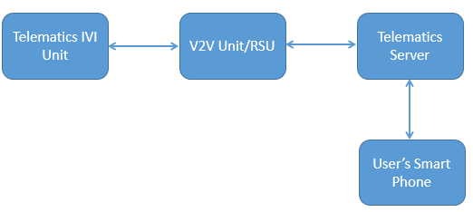

Figure 3.2 Project’s Methodology

The figure shown above explains the methodology as well as the flow of the project as it contains several blocks. The first block Telematics IVI unit will be mounted on the vehicle. The V2V unit consists of on-board unit helps in the communication purposes and facilitating several functions to the vehicles like location sharing and many more. The Telematics Server is used to collect all the diagnostic data of the vehicle, i.e. it captures all the necessary data and uses it when necessary. The User’s Smart Phone is the main component as it is only the unit which will handle all the units and will provide the facilities and functions to the user/ car.

**3.1.8 Testing :-**

Testing is the process of evaluating a system or its component(s) with the intent to find whether it satisfies the specified requirements or not. It is executing a system in order to identify any gaps, errors, or missing requirements in contrary to the actual requirements. All three functions provided by the Telematics App, i.e, Location Sharing, Remote Car Control and Vehicle Diagnostics are tested using different parameters and data strings. At the same time the Web Portal created is also tested whether all the features are working properly or not.

**3.1.9 Result & Conclusion :-**

All the research, testing and experimenting has led to a system based on the combined approach of VANET and Telematics, which offers more secure and faster message transfer between vehicles. In addition to that, the communication is also not dependent on the cellular networks.

### CHAPTER 4

**EXPERIMENTATION/ IMPLEMENTATION/ SIMULATION**

* 1. **Module Development :-**

The Proposed Project states to communicate between two Vehicles using VANET & Telematics. The proposed project is basically a simulation to a real world product, i.e a Car. This project is based on Client-Server Relationship, where Client resembles to our Mobile Application as well as Users. At the same time, the Server is our Laptop. The proposed Project is distributed into different modules for its complete implementation. These different modules combine together to form a complete project. The different modules of the project are listed below:-

4.1.1 Module-1 Client Development

4.1.2 Module-2 Server Development

4.1.3 Module-3 Arduino Programming

4.1.4 Module-4 Client-Server Connection

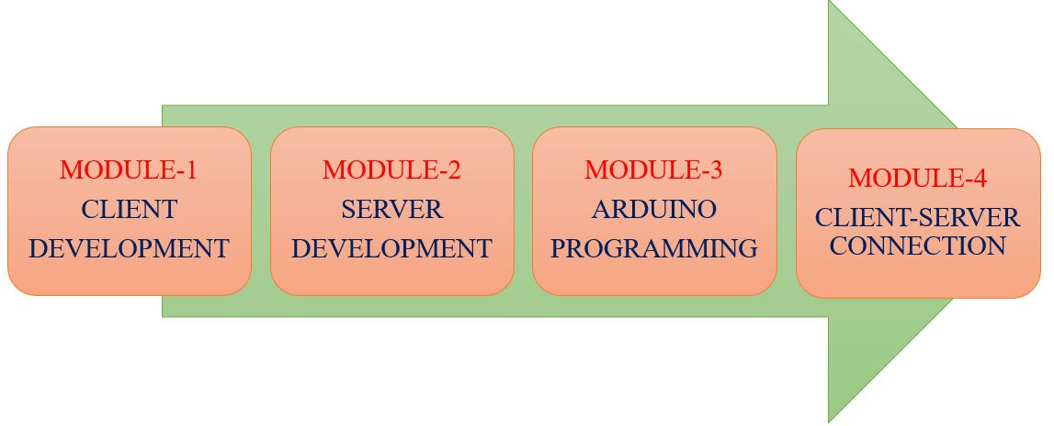

Figure 4.1 Modules of the Project

* 1. **Module-1 -- Client Development :-**

The proposed project consists of a Mobile Application as a Client. This Client communicates and send request to the Server for any purpose. In response to it the Server sends the response to that request. This client is basically a Mobile Application which is built via Android Software. The Client comprises of various functions, where each function is useful and relevant for the Vehicles. These functions will play a great role when used to communicate between two vehicles.

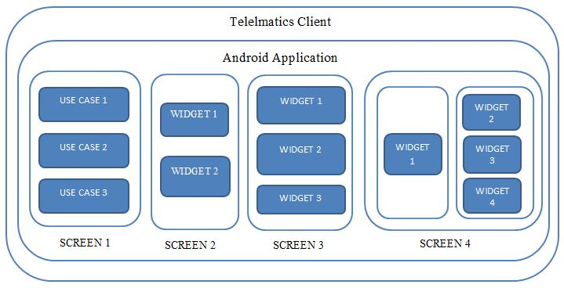

Figure 4.2 Client Implementation

The Figure 4.2 given above illustrates the client Implementation details, where the Use Cases represents the various functions provided by the App and the different Screens represents the facilities of that functions.The different Use Cases, i.e Functions included in the App are following :-

* Location Sharing
* Remote Car Control
* Vehicle Diagnostics

The detailed description on these functions are given further. The exact implementation, its uses and the major advantage of these functions are provided.

* **Location Sharing :-**

Location sharing is an important feature if you need to let a client, staff member, friend, or another person in on your whereabouts. This is a convenient way to allow specific contacts to keep track of your location in real time. Essentially, what you do is share your location with a contact. That location will then appear on your contact's Google Map app, so they can then use that location to quickly get directions to you. On the same phenomenon our App works, where the vehicles will be able to share its current Location to the another Vehicle. The Proposed project is performing it via Cellular Network but in real time product it will occur through VANET.

* **Remote Car Control :-**

This is the another feature provided by the Application wherein we can control our Remote Car via this App. The Remote Car is built with the NodeMCU as well as the Arduino Programming is performed on it. The Function has two buttons, i.e **Remote Engine Start**, which will help to start our car and move forward on pressing and **Remote Engine Stop**, which will stop our moving car on pressing this button.

* **Vehicle Diagnostics :-**

The Vehicle Diagnostics is the unique feature of this App, as it is basically used in real time either by the Automotive Company or the user of the Car. As the name suggests, this feature helps in the diagnosis of Vehicle like checking various parameters and faults in vehicle time to time. Through this we will be able to diagnose our vehicle in terms of Fuel level Detection, Air Pressure Level, Speed , Distance Covered and many more.

* 1. **Module-2 -- Server Development :-**

The Server is the main component of the proposed project , here our Laptop resembles to the Server of the project. The fundamental role of the Server is to accept the request of the Client and the Server sends the response of the particular request to the Client. The Server here, is composed of Front-end and back-End. The Front-end is the interface provided to the admin in the form of Web Portal which helps in keeping watch on the data gathered by the client. This web portal is designed with the help of technology like HTML, CSS, Javascript. At the same time, the server also consists of Back-end for handling the data, storing and retrieving it. The Back-end is developed by using the technology like Java and SQL.

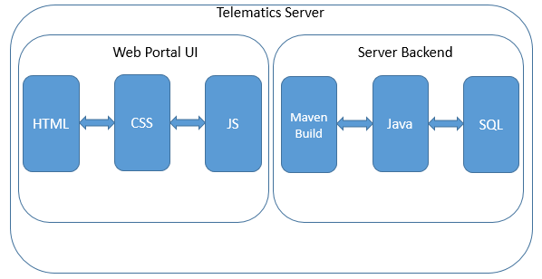

Figure 4.3 Server Implementation

The figure 4.3 illustrates the implementation of the Server with two components as well as the technology to develop both the components. The actual pictures of the Server is given in further section, i.e. Result.

* 1. **Module-3 -- Arduino Programming :-**

The module -3 , i.e. Arduino Programming is basically utilized in the Remote Car Control feature. In this feature, we have a Remote car developed with some hardwares mainly, NodeMCU which has inbuilt Wi-Fi. Thus via Arduino Programming we have connected the the Car’s Wi-Fi with our hotspot and then lastly the proper coding has been done for Starting & Stopping the Remote Car through our App. The figure 4.4 given below describes the complete architecture of the Remote Car Control function.

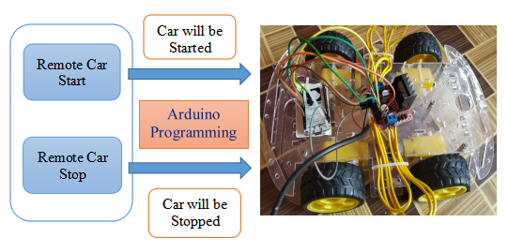

Figure 4.4 Remote Car Control Architecture

* 1. **Module-4 -- Client-Server Connection :-**

The last module, i.e. Client- Server Connection is the most important module. As we have already seen that the Client & the Server has been developed separately on different platforms. Thus, these both re integrated with the help of HTTP protocol. The HTTP Client is used for the client side in the Android App, whereas the Server is designed with HTTP Server. These both communicate with each other and sends and receive the request and response respectively. Whenever the Client sends any request to the Server then the server accepts the request it, store it and respond it equally. At the same time, the Server is also responsible for the data storage and display.

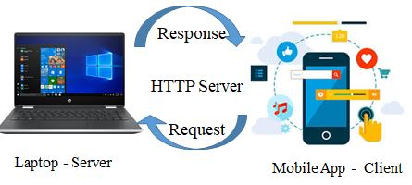

Figure 4.5 Client - Server Connection

The figure 4.5 given above illustrates the Client - Server Connection, provided that the Client is our Mobile Application and the Laptop functions like a Server. The mediator between the both is the HTTP as shown in the figure.

### CHAPTER 5

**RESULTS AND DISCUSSIONS**

This chapter describes the result of the proposed project, i.e V2V Communication Approach towards Autonomous Driving using VANET & Telematics. It will give the output of different modules which has been designed to implement the complete project. The various techniques, algorithms and technology is utilized to perform different modules as per the requirement.

* 1. **Client Side - Mobile Application :-**

As already mentioned that, the Mobile Application symbolizes to the Client in the proposed project. Basically, app provides certain features which is basically used for specific purpose.

**5.1.1 Client’s Login Page :-**

Initially, the App named Telematics App has been developed and after launching the App , the first screen is the Login Page which helps the users to explore the features with authenticated credentials.

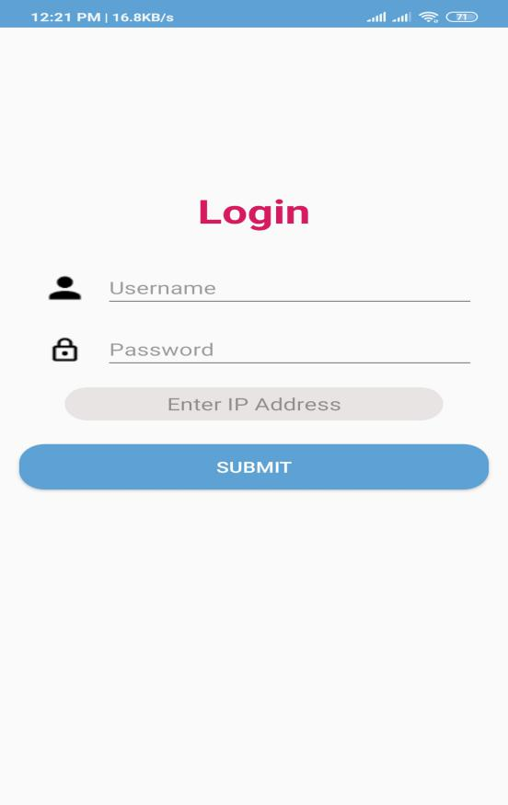

Figure 5.1 App’s Login Screen

The Figure 5.1 represents the Login page which is the first and the foremost page of the App. This page asks 3 data of the user, i.e. Username , Password & IP Address. The user should enter there relevant username and password, where as IP Address is the IP Address of the Server. After filling the required details, the user will press the Submit button and will move further.

**5.1.2 Client’s Home Page :-**

Once the user fill its credentials in the Login page, it is able to explore the Functionaities provided by the App. There are three core functions present in the App .

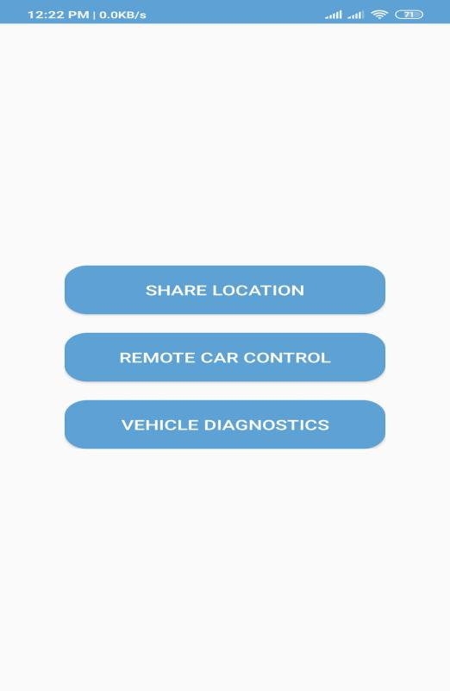

Figure 5.2 App’s Home Screen

The figure 5.2 represents the Home page of the Telematics App. This page comprises of 3 functions, i.e, Location Sharing, Remote Car Control, Vehicle Diagnostics.

**5.1.3 Location Sharing :-**

The very first function provided by the Telematics App is the Location Sharing. In this function, we will initially access our current location through the GPS enabled in our mobile and then will be able to share this current location to the another user. Thus considering it for the Vehicles, it is very useful and will help in keeping track of our contacts. Here, it is using cellular network but in the real world product it will use VANET.

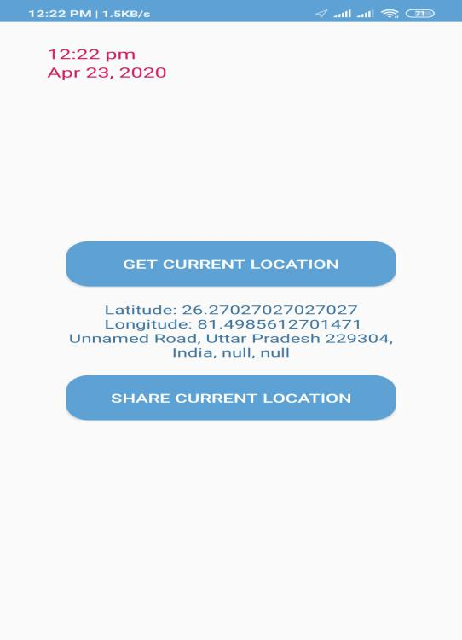

Figure 5.3 Location Sharing Screen

The figure 5.3 represents the Location Sharing Page which has two particular buttons, i.e, Get Current Location & Share Current location.

**5.1.4 Remote Car Control :-**

The another important feature provided by Telematics App is Remote Car Control, i.e. through this feature the user will be able to control its car remotely. On a single button press, the Engine of the car will be started as well as stopped.

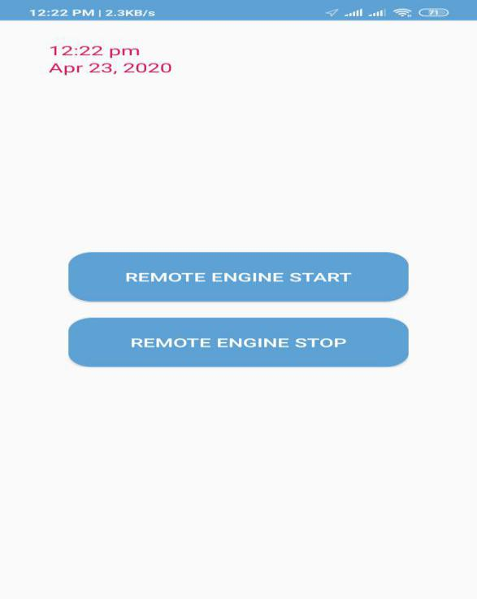 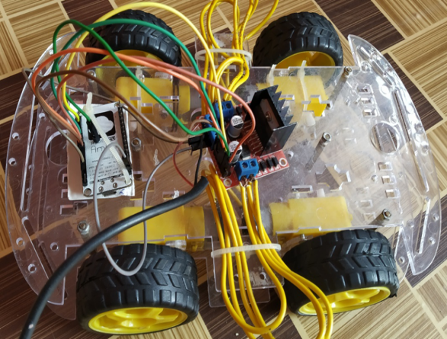

Figure 5.4 Remote Car Control Screen Figure 5.5 Remote Car

The Figure 5.4 represents the page of Remote Car Control feature. There are two buttons given, i.e, Remote Engine Start & Remote Engine Stop which enables the remote car to start & stop respectively. The figure 5.5 gives the remote car which is connected with our App.

**5.1.5 Vehicle Diagnostics :-**

Last but not the least, the next feature is Vehicle Diagnostics which enables to diagnose our car with several parameters like Air Pressure, Fuel level, Distance and can be more extended. This feature is helpful not only in the industry but also for the lay users.

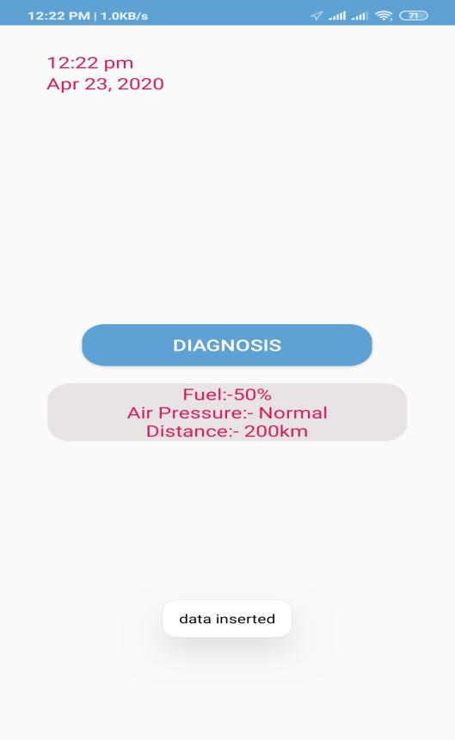

Figure 5.6 Vehicle Diagnostics Screen

The figure 5.5 represents Vehicle Diagnostics Screen in which one button is provided. Once the button is pressed the diagnostics is performed and the result is displayed.

* 1. **Server Side - Web Portal :-**

The another main component of the project is the Server and as it is already mentioned that our laptop acts as a Server. We have designed a web portal for its proper handling which at the same time is also connected with the MySQL database .

**5.2.1 Server’s Login Page :-**

This portal is basically to maintain the integrity and privacy of data so that the authorized admin can keep watch on the data. The admin is already registered in the database. He will be able to login this web portal with the specific credentials.

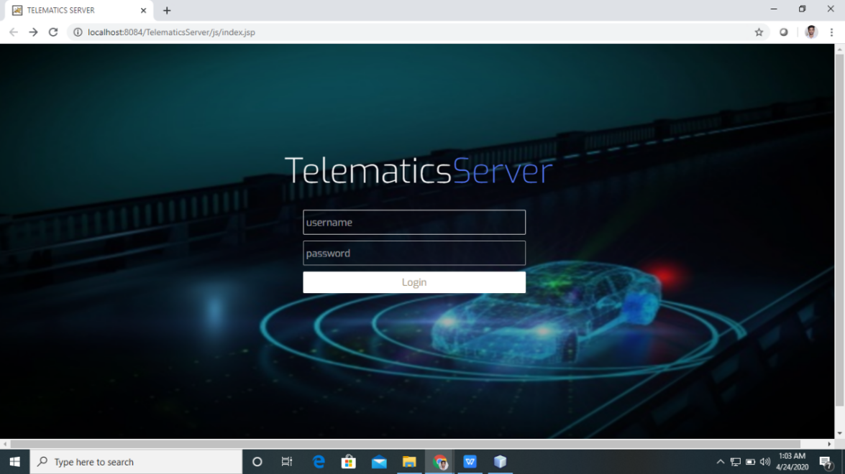

Figure 5.7 Server’s Login Page

The Figure 5.7 represents the Login page of the Web Portal which usually comprises of Username & Password.

**5.2.2 Server’s Home Page :-**

Similarly to the Telematics App, this web portal also consists of Home Page which displays all three functions. The admin will choose that he wishes to view which of the following data.

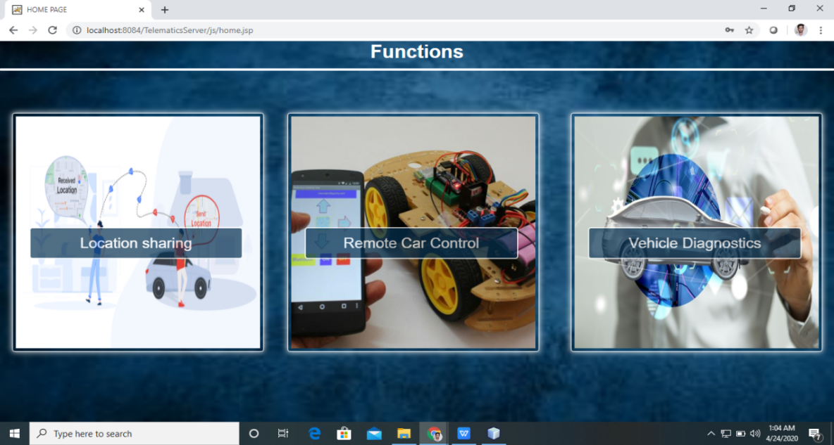

Figure 5.8 Server’s Home Page

The figure 5.8 represents the Server’s Home as it helps the admin to keep track of the record of the functions provided by the App.

**5.2.3 Location Sharing’s Data :-**

This tab of the portal describes the data being shared by the app in terms of location Sharing. The admin will be able to view the complete information of the data being shared by the App like Latitude, Longitude, Address and many more.

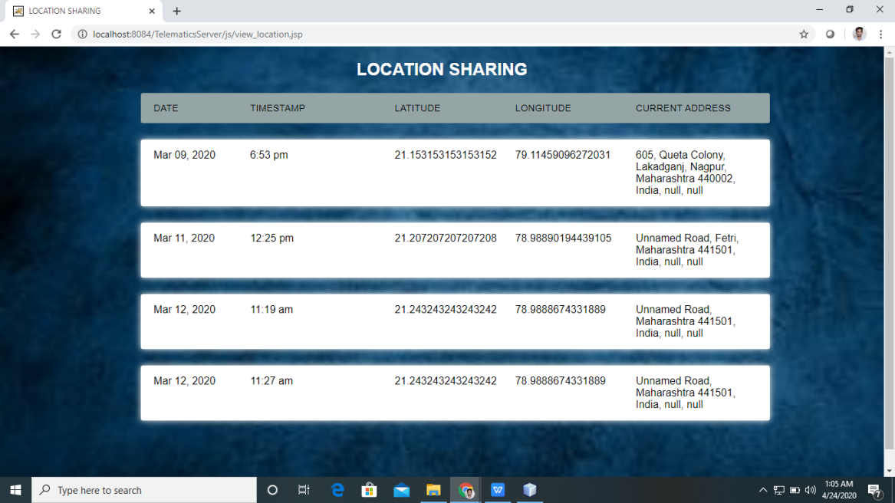

Figure 5.9 Location Sharing’s Data

The figure 5.9 represents the Location Sharing’s Data as it comprises of table with specific columns like Date, Timestamp, Latitude, Longitude, Current Address of the person which shares this information from the App.

**5.2.4 Remote Car Control’s Data :-**

This tab gives the description of the data being accessed in terms of Remote Car Control. As this feature consists of Remote Engine Start & Stop in the App.

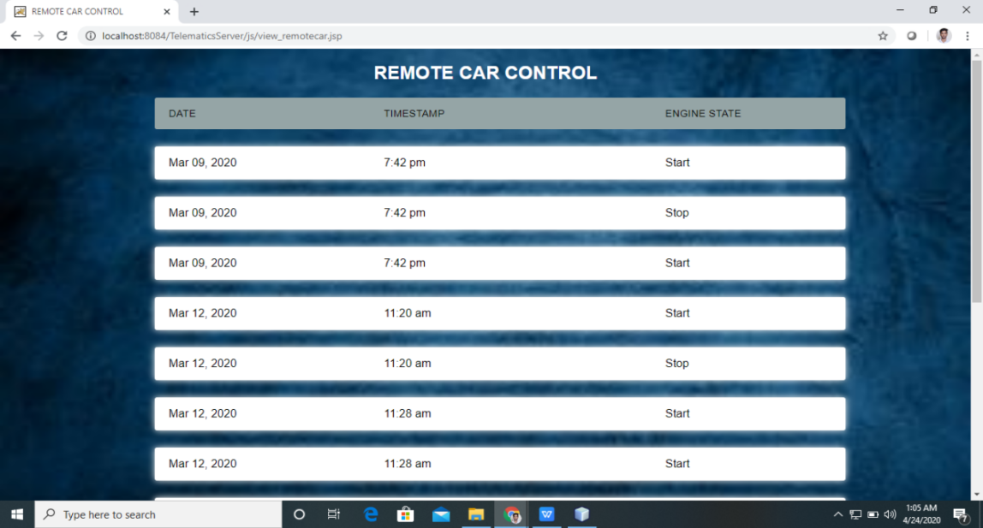

Figure 5.10 Remote Control Car’s data

The figure 5.10 represents the Remote Car Control’s Data as it comprise of table with specific columns like Date, Timestamp & Engine State.

**5.2.5 Vehicle Diagnostics’s Data :-**

Lastly, there is a tab which gives the detail description of data of Vehicle Diagnostics’s. The admin will be able to view all the data related to this feature like result of the diagnosis.

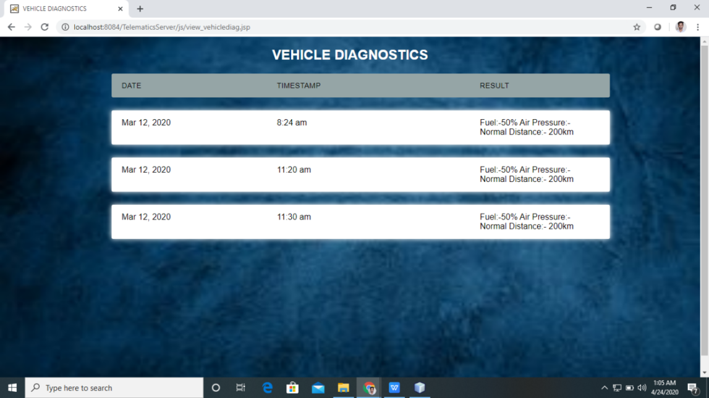

Figure 5.11 Vehicle Diagnostics’s Data

The figure 5.11represnts the Vehicle Diagnostics’s Data which comprises of table consisting of columns like Date, Timestamp & Result.

### CHAPTER 6

**SUMMARY AND CONCLUSION**

* 1. **Summary**

The importance of vehicles in the daily human life is well known to everyone. And with the new technologically advanced era we are stepping in, the vehicles should also be upgraded a bit as per the advanced technology. The proposed project offers an insight based on the same concept. It is basically a system designed with the help of two main technologies- VANET and Telematics. Both of these in a combination helps the user to make more secure and faster vehicle to vehicle communication within a particular radius. The proposed project offers mainly three functions- Remote Car Control, Location Sharing and Vehicle Diagnostics. The function Remote Car Control facilitates the user to either start or stop the vehicle engine with the help of their Android application. Location Sharing enables their location to be shared to any other user they want, while Vehicle Diagnostics will notify the user about various conditions in the vehicle like fuel level, gas level or any other defect that needs to be repaired directly on their mobile phones.

* 1. **Conclusion**

The proposed project is based on a combination of VANET and Telematics which are proven to be very reliable and faster in the case of message sharing among the vehicles. Moreover, it eradicates the chances of inconvenience to the user due to depending on the cellular networks as the vehicles will be connected by Vehicular Ad-Hoc Network.

* 1. **Scope for Future Work**

Every project has the scope of extension in different terms. Therefore, this project also has the scope for future work like the app developed can be extended with more features as well as the portal will be able to extend. This project is a prototype to the real world product. So the implementation of this prototype to the real world product is also a major challenge in future.

**REFERENCES**

1. Michal Taraba, Juraj Adamec, Matus Danko, Peter Drgona (2018), “Utilization of modern sensors in autonomous vehicles,” 978-1-5386-4759-2/18/$31.00 ©2018 IEEE.
2. Shouyang Wei, Yuan Zou, Senior Membe (2018), “An Integrated Longitudinal and Lateral Vehicle Following Control System with Radar and Vehicle-to-Vehicle Communication,” 0018-9545 (c) 2018 IEEE.

[3] Giuseppe Lugano ERAdiate team, (2017),” Virtual Assistants and Self-Driving Cars: To what extent is Artificial Intelligence needed in Next-Generation Autonomous Vehicles?,” 978-1-5090-5275-2117/$31.00 ©2017 IEEE.

[4] Youngho Park, Chul Sur, Si-Wan Noh and Kyung-Hyune Rhee(2017), “Secure Vehicle Location-Sharing for Trajectory-Based Message Delivery on VANETs,” IEEE, 2017.

[5] T.Banerjee1, S.Bose2, A.Chakraborty3, T.Samadder4,Bhaskar Kumar5, T.K.Rana6 (2017)”Self Driving Cars: A Peep into the Future,” 978-1-5386-2215-5/17/$31.00 ©2017 IEEE.

[6] S. Hassler, "Self-Driving Cars and Trucks Are on the Move. How and when will they affect jobs and drivers?", IEEE Spectrum, vol. 54(1), 2017, p.6.

[7] Asim Rasheed, Saira Gillani, Sana Ajmal and Amir Qayyum (2017),” Vehicular Ad Hoc Network (VANET): A Survey, Challenges, and Applications,” © Springer Nature Singapore Pte Ltd. 2017 A. Laouiti et al. (eds.), Vehicular Ad-Hoc Networks for Smart Cities, Advances in Intelligent Systems and Computing 548, DOI 10.1007/978-981-10-3503-6_4

[8] Lv, H. Zhu, H. Xue, Y. Zhu, S. Chang, M. Dong, and M. Li (2016), “An Empirical Study on Urban IEEE 802.11p Vehicle-to-Vehicle Communication,” in Proceedings of IEEE SECON, 2016.

[9] Pavel Shilin, Ruslan Kirichek(&), Alexander Paramonov, and Andrey Koucheryavy (2016), “Connectivity of VANET Segments Using UAVs,” © Springer International Publishing AG 2016 O. Galinina et al. (Eds.): NEW2AN/ruSMART 2016, LNCS 9870, pp. 492–500, 2016. DOI: 10.1007/978-3-319-46301-8_41.

[10] Qudsia Memon , Muzamil Ahmed, Shahzeb Ali, Wajiha Shah, Azam Raﬁque Memon, (2016), ‘’Self-Driving Michal Taraba, and Driver Relaxing Vehicle,” 978-1-5090-4059-9/16/$31.00 ©2016 IEEE.

[11] Felipe Cunha, Aline Viana, Leandro Villa, Azzedine Boukerche and Raquel A. F. Mini (2016), “Data communication in VANETs: Protocols, applications and challenges”, 1570-8705/© 2016 Elsevier B.V. All rights reserved,2016.

[12] Lv, H. Zhu, H. Xue, Y. Zhu, S. Chang, M. Dong, and M. Li (2016), “An Empirical Study on Urban IEEE 802.11p Vehicle-to-Vehicle Communication,” in Proceedings of IEEE SECON, 2016

[13] F. Kroger, "Automated Driving in its Social, Historical and Cultural Contexts", in Autonomous Driving, Berling, Springer, 2016, pp. 41-68.

[14] P. Lin, "Why ethics matters for autonomous cars", in Autonomous Driving, Belrin, Springer, 2016, pp. 69-85

[15] Dhivyasri G, RajeswariMariappan (2015), “Advanced Fuel Level Tracking System Using Telematic Unit,” 978-1-4799-6085-9/15/$31.00 ©2015 IEEE.

[16]Ed Novak and Qun Li (2014), “Near-Pri: Private, Proximity Based Location Sharing,” IEEE INFOCOM 2014 - IEEE Conference on Computer Communications,2014.

[17] Takatomo Yamabe, Ryozo Kiyohara (2014), “A Study of on-Vehicle Information Devices Using a Smartphone,” 978-1-4799-3578-9/14 $31.00 © 2014 IEEE DOI 10.1109/COMPSACW.2014.9”

[18] Sharma P., Verma P., Pal A.,“ Electrical Designing Of Solar Car” , International Journal of Electronics, Electrical and Computational System IJEECS ISSN 2348-117X Volume 3, Issue 3 May 2014.

[19] Debasis Das, Rajiv Misra (2014), “Efﬁcient Vehicle to Vehicle Communication Protocol for VANETs,” 978-1-4799-2291-8/14/$31.00 c 2014 IEEE

[20] Ryosuke Otsuka, Shinji Kitagami, Yoshiaki Terashima (2014),”Improved Location Estimation Based on the Pressure Sensor for Car Navigation System ,’’ 978-1-4799-1291-9/14/$31.00 ©2014 IEEE

[21] Danda B. Rawat, Bhed B. Bista, Gongjun Yan, and Stephan Olariu, (2014)” Vehicle-to-Vehicle Connectivity and Communication Framework for Vehicular Ad-Hoc Networks,” 978-1-4799-4325-8/14 $31.00 © 2014 IEEE DOI 10.1109/CISIS.2014.7.

[22] Deshpande, Pawan. "Road Safety and Accident Prevention in India: A review." Int J Adv Engg Tech/Vol. V/Issue II/April- June 64 (2014): 68.

[23] Francesco Malandrino and Marco Fiore (2013), “Optimal Content Downloading in Vehicular Network,” IEEE Transactions On Mobile Computing, Vol. 12, No. 7, July 2013.

[24] Ke Xu, Orlik, P.V., Nagai, Y., Saito, M., “Location Based Data Delivery Schedulers for Vehicle Telematics Applications”, Proc. Of IEEE Vehicular Technology Conference (VTC Fall), pp. 1-5, 2012

[25] Chung-Ming Huang, Chia-Ching Yang and Chun-Ming Hu (2010),” An Efﬁcient Telematic sService Discovery Scheme over the Centralized Vehicular Peer-to-Peer(C-VP2P)Telematics Service Platform” 1550-445X/10 $26.00 © 2010 IEEE DOI 10.1109/AINA.2010.89.

[26] Campbell, Mark, Magnus Egerstedt, Jonathan P. How, and Richard M. Murray. "Autonomous driving in urban environments: approaches, lessons and challenges." Philosophical Transactions of the Royal Society A: Mathematical, Physical and Engineering Sciences 368, no. 1928 (2010): 4649-4672

[27] Campbell, Mark, Magnus Egerstedt, Jonathan P. How, and Richard M. Murray. "Autonomous driving in urban environments: approaches, lessons and challenges." Philosophical Transactions of the Royal Society A: Mathematical, Physical and Engineering Sciences 368, no. 1928 (2010): 4649-4672

[28] Yue Liu1, Jun Bi2, Ju Yang1(2009) “Research on Vehicular Ad Hoc Networks” 978-1-4244-2723-9/09/$25.00 c 2009 IEEE.

[29] William J. Fleming- Life senior member IEEE "New Automotive Sensor - A Review" IEEE Sensor Journal, vol. 8, no. II, November 2008

[30] G. J. Capps, O. Franzese, H. E. Knee, R. S. Plate, M. B. Lascurain, “Wireless Roadside Inspection Proof of Concept Test Final Report”, ORNL/TM-2008/128, Oak Ridge National Laboratory (2008).

[31] Jing Zhao, and Guohong Cao, VADD: Vehicle-Assisted Data Delivery in VehicularAdHocNetworks,IEEETransactionsOnVehicularTechnology, Vol. 57, No. 3, May 2008

[32] Kerstin Zimmermann (2002), “A Research Information Portal for Telecommunications,” 0-7803-7824-0/02/%10.00 02002 IEEE.

[33] IEEE 802.11, The Working Group Setting the Standards for Wireless LANs. http://www.ieee802.org/11/

[34] Building Telematics Server https://www.instructables.com/id/DIY-Telematics-Box/

[35] Ultra wide band planet. com. http://www.ultrawidebandplanet.com/.

[36] ZigBeeAlliance.http://www.zigbee.org/.